The 3 Pies of Yorkshire………. Never Again !! Date 22nd June 2007

Up for it were:
Keithee’s up for it, Heavy Steve Machine, Yupmeister, Midweek Tone, Spikelet, Scottee, Chris ‘Flash’ Jackson, Pedro, Stubbee, Hecky Thump and Stir Fry (Stew).

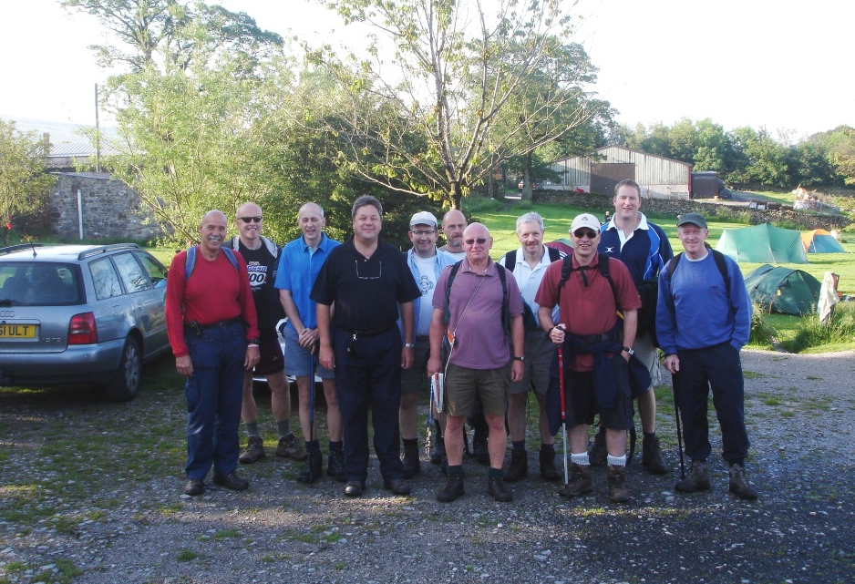

Was there ever any doubt that we’d cancel this trip due to the weather….. Nah, not really!! Forecasts had included torrential storms, flood warnings, heavy rainfall, thunder and lightening. The possibility of being stuck on top of a mountain with metal walking sticks in lightening storms came to mind, and belated consideration was given by some (ergh, ergh) to staying in a comfortable guest house instead of a damp tent. But Keithee held firm and declared on the Wednesday that the walk with overnight camping would go ahead as planned. The challenge of the 3 pies of Yorkshire was very much alive. And with Yuppy with us, an oasis of sunshine would surely follow us. (And guess what !!!)

Keithee and Pedro had set off as the advanced party on the Thursday afternoon. The journey should have been straight forward; however the monsoon conditions were causing aquaplaning at 50 miles per hour so it took a bit longer than anticipated. Upon arrival the rain had subsided to mild monsoon conditions and as it appeared to have set in for the duration they decided to pitch the tent and to hell with it. It took the experienced campers just seconds to throw the tent up and make it habitable (yea really!). That done, the rain stopped and Pedro appeared with a bottle of red wine, mmm red wine, and a couple of genuine plastic camping wine glasses. This was the beginning of being sensible and not having too much to drink on the eve of the walk.

It wasn’t long before the rest of the gang arrived and pitched their tents, before making their way to the Golden Lion………………. except, that is, for Yup, Stub and Mid week Tone who were still on the motorway. What could possibly have gone wrong? ………..

Well, there was just a minor problem with horrendous tailbacks on the motorway, even before an accident occurred which was witnessed by Flash. He had quickly changed into his ‘Flash’ gear and flew straight to the rescue of a driver whose car had flipped over, before continuing up to his parent’s house in Clitheroe in civilian clothes. The motorway was later closed.

Much more seriously though for the lads in the yupmobile was the realisation that Stubbie had forgotten a 4 pint bottle of milk. Oh what a crisis! How were we going to eat dry sugar puffs the following morning?

Worse followed……. Mrs Yup rang to confirm she’d found tent poles lying on the garage floor…. Oops. Could this have been the chance Yup was looking for to book into a warm and cosy guest house for the night instead of lying on a damp patch of grass in a farmer’s field? Was it deliberate? Shrouded in guilt however, he used his initiative, and a minor detour to purchase a cheap 2 man tent saved his bacon. Finding a cow to replace Stubbie’s milk however proved slightly more difficult.

When they finally arrived, the midges on the camp site were biting like fury, so the tents were set up at breakneck speed before joining the earlier arrivals in the Golden Lion which was quite conveniently situated next to the site. The guard dog’s bark frightened the living daylights out of them mind, as they slipped by the farmer’s house and up the drive to the pub. They were ready for a pint to settle their nerves.

The earlier arrivals were settled in the back room of the pub, perched on hard, spring-less seats, and were surrounded by hundreds of blow torches! Perhaps the winters are dreadful? Most were taking it easy on the drink front, and restricting their intake to just a couple of pints or three. Pedro and Keithee were the exception to the rule though, having earlier necked that bottle of Shiraz, and were now seen slipping down their umpteenth pint of ale. Noticeably, only two were on lager, one of whom was christened Sir Stew; or was it Stir Fry, I forget.

Yup reminisced over the last time he had tortured himself in completing the 3 peaks walk and his recollection of the size of Pen y Gent. On arriving tonight he recalled feeling that either Pen y gent appeared bigger, or else he’d shrunk. ‘Oh no you haven’t’, came the chorus of replies.

The missing poles tale slowly emerged with Yup dishonestly explaining that all was well now with his tent, as he’d nicked a pole off every other dishevelled looking tent in the field.

Flash’s anticipated appearance tomorrow was mentioned and his claim to fame in the Guinness book of records for his feats of strength came to light. Scottee wasn’t that impressed and said he had a friend who was also in the book of records for slicing cucumber!

The barmaid was an asset according to Spikelet; and we agreed whole heartedly. After a few pints of Timothy Taylor’s Landlord we agreed even more whole heartedly. The last orders for food were taken at 9pm. ‘Well done’ steaks were the favourite orders taken but they were served incinerated on the outside and pink in the middle. Steve was not impressed and turned to his half pint of lager but struggled to finish that too. At least we whole heartedly agreed that the barmaid was an asset.

An early night was necessary so we slipped back to the camp site and our damp sleeping bags to set our alarms for 5.30am. Several loud bangs were heard from Yup’s new tent. ‘Was that the sugar puffs exploding?’, Stubbie shouted from the adjacent tent, as Tony attempted to stop further buttons from popping off his blow up doll mattress.

Flash and Hecky Thump arrived bright and early the following morning. Flash, fresh from his parent’s house in nearby Clitheroe; and Hecky Thump after an early start from Hednesford.

Milk miraculously appeared for the sugar puffs and all was well, until the smell of bacon wafted over from Scottee’s frying pan.

We were almost ready for the 7am start but time drifted and after pushing the registration details of the group through the door of the post office we set off up Pen y gent nearer 7.30.

As we neared the first summit Pedro, suffering vertigo, clung tightly to the rocks and never looked down. He was not on his own. Yup had got his first pie out to begin the 3 pie challenge. One pie down, 2 more to go.

Flash, with 2 apples and no water provisions, along with Heavy Steve Machine, with a stone in his shoe, could be seen disappearing off into the distance to complete the distance in record time. If only Steve had had enough time to stop and remove the stone from his shoe!

The boggy stretch across the next valley bore plenty of evidence of the previous bad weather. Maybe the weather had also realigned the pathways because at one stage there was some slight confusion over the route. Scottee accused the Ordnance Survey of producing inaccurate maps.

A large crevasse proved worthy of a minor 20 yard detour off the path complete with a waterfall disappearing into the fissures below. Mid week Tone and Keithee who had slipped ahead at this point opted to conserve their energy and wait for the photographs.

The viaduct eventually came into view, followed by the welcoming site of the infamous ‘powdered tea’ van nestled at the side of the road. Tea and water rations were taken on board as we took our first rest by the stream. The proprietor confirmed to Spike that he’d been doing same job for 17 years and that whenever anyone asks him how long to the next train, his response was always half an hour. Very helpful! And wouldn’t you have thought that after 17 years he’d have bought a bin for the rubbish instead of a carrier bag hanging off the door?

It was a long pull up Whernside, with Yup and Spike opting to enjoy the views and admire the civil engineering feats, including the aqueduct passing over the railway route. The rest made their way up to the summit taking bets on whether Yup and Spike would make the complete route. There was never a doubt. 2/3 pie was soon achieved, followed by a break in the pub, the Inn on the Hill, with a delightful barmaid.

Towards the third peak the gang of seven, realising now that Yup and Spike were safely at the pub, decided to make a bid for the 12 hour challenge. Heads down they scaled the last peak. The view from the top was awesome with clear views of the surrounding storm fronts. The long trudge from Ingleborough back to Horton nearly took another victim in Mid-week Tone with stomach cramps. A pie might have helped? Still, he soldiered on, and with the assistance of Pedro made it to the end within the 12 hours. Stir Fry was suffering with sore feet, after not doing any walking for 12 months, but pushed to cross the line along with Keithee, Scottee, Windy Stubby and Hecky Thump.

A quick change of footwear and the party wandered over to the Golden Lion to find Heavy Steve Machine sitting on his own after finishing the challenge in an amazing 8 hours. Steve later went on to finish a second, then a third evening meal before removing the stone from his shoe.

Yup and Spike meanwhile, crawled up the steps on the last leg up Ingleborough as threatening clouds collected over Whernside behind them. One look from Yup and the storms receded and slipped off angrily in a southern direction towards Settle. Spike meanwhile struggled to get a signal on his phone to say his goodbyes to his daughter Helen who announced she was leaving home the following day. Yup waited patiently and completed his pie challenge in Ali Gees honour. 3 pie aaah.

It was generally agreed that the pull off from Ingleborough was incorrectly signed. A 1¾ mile fingerpost was passed, sited around 5 miles from where it should have been.

With phone signal strengths at their peak, contact was made with Yup and Spike. Arrangements were made for well earned pints and meals to be prepared for them after they had fooled everyone by going on to finish the walk in another record breaking time of 14 hours. Stir and Flash by this time had gone home and missed out on the evenings celebrations.

It was a satisfying smug evening for the remaining weary, but elated, bunch of squarrites. Everyone was truly knackered but the challenge had been won. Several had been sucking on Ibuprofen throughout the day which had obviously worked better than the pies. Congratulations must go to everyone for their determination in successfully completing the challenge.

A few pints later and we crept back to our tents and collapsed onto our sleeping bags; too knackered to unzip and slide into them.

‘That’s my bottom hole’, was heard from an adjacent tent as the whispers subsided and the snoring slowly grew. The next morning the campers were all eager to sneak a curious peak at the sheepish looking victim. The farmer who owned the campsite was also sneaking around, particularly around the shower block, pretending to check on the stock of toilet rolls.

‘3 Peaks Special’ and the ‘Dales Special’ breakfasts were consumed in the Settle-down café, before visiting a Craft Centre to purchase real ale gifts for the wives.

It was great finally to return home to a hot bath, a gnat free environment, and a comfy chair. Several days later and the gnat bites had stopped itching; the aching legs and pains had subsided, and we were ready to do it again. Ooo. Did somebody just wake me up?

Yupmeister

Never again?

PS Thanks go to Keithee for maintaining a determined push in going ahead with the challenge, despite the discouraging weather forecasts which were unfounded and the desperate attempts by some for it to be cancelled. As if ….

